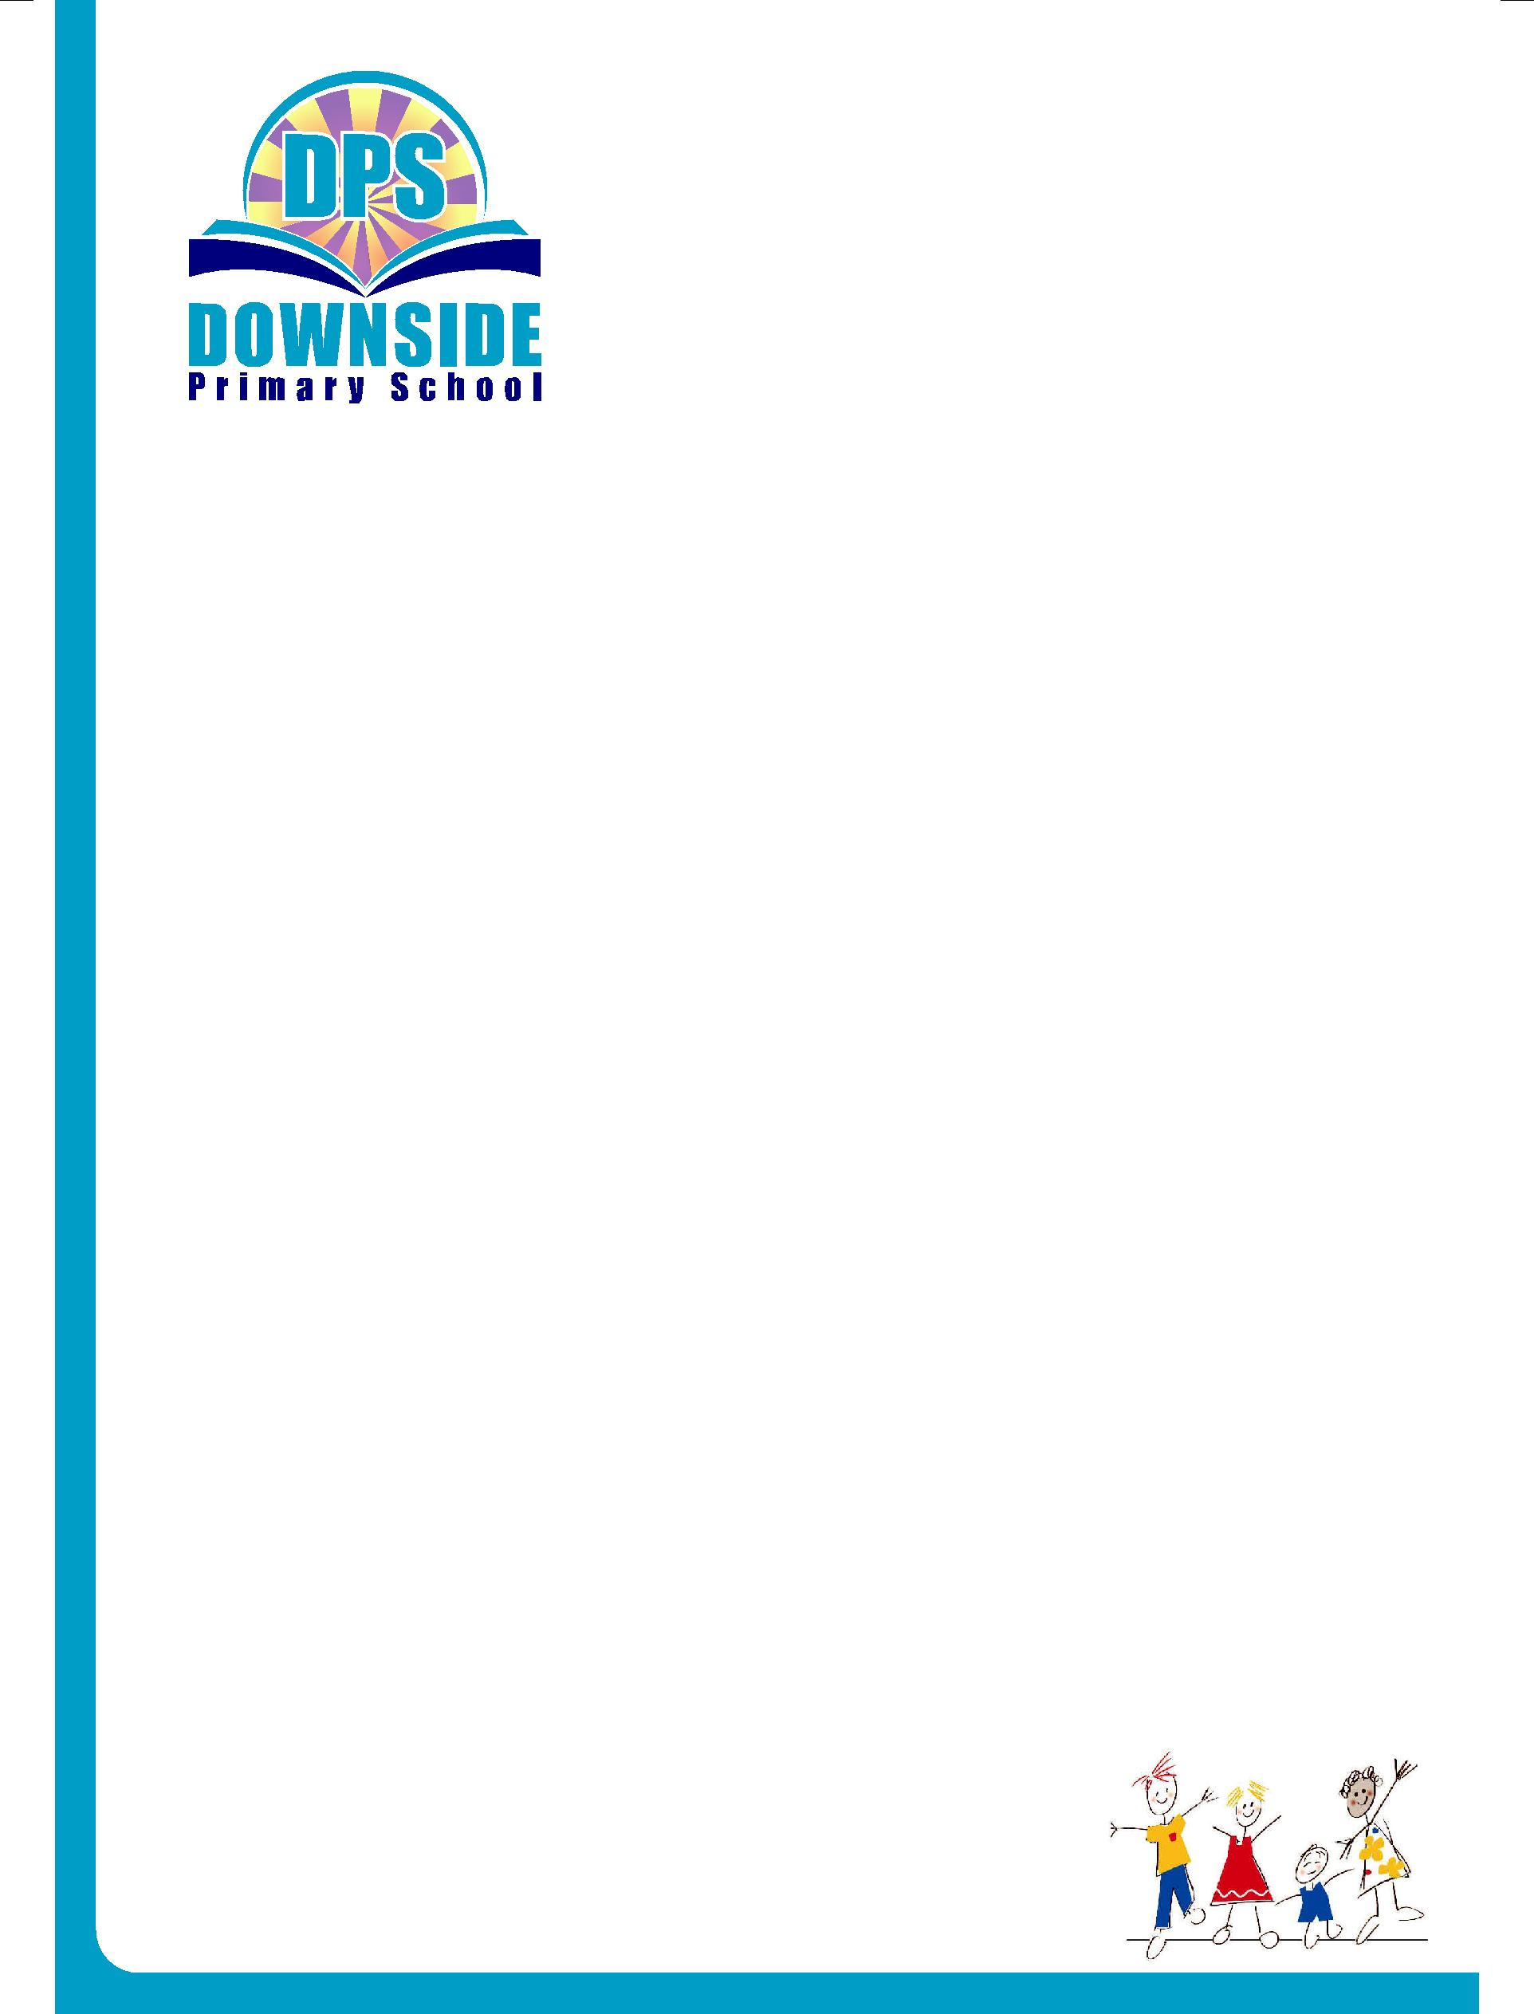

Downside Primary School

Chaul End Lane, Luton,

Bedfordshire LU4 8EZ

T: 01582 587160

E: dpsadmin@downside-primary.co.uk
W: www.downside-primary.co.uk

Headteacher: Miss Karen Hooker

September 2026

Dear parents and carers of Year 3 children,

I would like to take this opportunity to welcome everyone back to school and to thank you for your support and patience with us in the first few weeks. It has been truly wonderful to have everyone back. I am pleased with how well the children listen and how quickly they are getting used to working in a new year group.

Literacy:

In Literacy, our teaching will be broadly in line with the following plan:

Week 1 | Grammar:  -formation of nouns  -expanded noun phrases  -co- ordinating conjunctions
Week 2 | Non Chronological report:  - know some features of an information report  - use questions to find out information
Week 3 | Non Chronological report:  - present information on a subject  - use co-ordinating conjunctions (or, and, but) and subordinating conjunctions (if, that, because)
Week 4 | Non Chronological report:  - use present and past tense correctly  - create a plan for information writing  - use a plan to write an information report  - edit and improve a sentence
Week 5 | Narrative:  - draw inferences about a character’s actions and feelings  - understand and recall a new story  - Use prepositional phrases in different parts of a sentence
Week 6 | Narrative:  - collect ideas for a traditional tale story  -understand and create multi-clause sentences
Week 7 | Narrative:  - plan a traditional story  - write a quest story using the techniques taught this half term  - edit and improve a section of writing
Week 8 | Poetry:  - understand what a poem is describing  - understand the key features of a poem  - identify and use verbs, nouns, adjectives and prepositions

Maths:

In Maths, our teaching will be broadly in line with the following plan:
Week 1 | Place Value:  - understand what 100 is  - understand numbers to 1000  - understand place value in a 3-digit number  - understand and compare place value in 3-digit numbers
Week 2 | Place Value:  - estimate, work out and write numbers on a number line  - find ten more and ten less than any given number  - find 100 more and 100 less than any given number
Week 3 | Place Value:  - compare objects to 1000  - order 3-digit numbers  - count from 0 in multiples of 5
Week 4 | Addition and Subtraction:  - mentally add and subtract multiples of 100  - mentally add and subtract 3-digit and 1-digit numbers  - mentally add 3-digit and 1-digit numbers using an exchange  - mentally subtract a 1-digit number from a 3-digit number using an exchange
Week 5 | Addition and Subtraction:  - add and subtract a 3-digit number and a 2-digit number that is a multiple of 10  - add and subtract a 3-digit number and a 2-digit number that is a multiple of 10 using an exchange  - add a 3-digit number to another 3-digit number that is a multiple of 100  - subtract a 3-digit number that is a multiple of 100 from another 3-digit number
Week 6 | Addition and Subtraction:  - spot patterns involving +/- 10 and 100  - solve word problems using knowledge of adding 100s, 10s and 1s  - add and subtract 2-digit and 3-digit numbers that are not multiples of 10
Week 7 | Addition and Subtraction:  - add 2-digit and 3-digit numbers using an exchange  - add 2-digit and 3-digit numbers using the formal column method  - subtract 2-digit from 3-digit numbers using the formal column method
Week 8 | Addition and Subtraction:  - add and subtract two 3-digit numbers using the formal column method both without and with an exchange  - understand how reasonable an answer is through estimation

Science:
In Science, we will be learning about humans and food. The children will learn the names and functions of different teeth and investigate the link between sugary drinks and tooth decay. They will then learn the names and functions of the digestive system and the role of fibre in moving waste through the body. The children began learning about food groups in KS1 and, this half term, they will revisit this and understand that when we eat more than we need, our bodies store the excess as fat.

History:
Our first History unit will be about the Stone Age. Firstly, the children will learn that the Stone Age is made up of three time periods: Palaeolithic, Mesolithic and Neolithic. They will also find out that humans had to be resourceful to live in the Stone Age. They will focus on the use of tools and the development of materials and hunting. The children will learn that cave paintings; early tools such as flints and fire hearths and settlements such as Skara Brae are all evidence that the Stone Age existed. Finally, the children will get to take part in some very special hands on workshops led by a fantastic team of people.

The Stone Age day event will be on the following days:

King and Emperor -Friday 11th September 2026

Rockhopper, Adelie and Humboldt - Thursday 17th September 2026

RE:
Our RE this term will revolve around the topic, ‘Where, how and why do people worship?’ As a part of this unit, the children will learn about various religious places of worship such as a Gurdwara and a Church. The children will have the chance to demonstrate the knowledge they have gained by completing various tasks such as report writing, postcard writing and drawing simple diagrams.

Computing:
During computing lessons, the children will understand computer networks and how they can be connected to each other. They will identify what input, process and output are as well as learning how a computer network can be used to share information.
Art:
In Art this half term, we will be looking at still life (an arrangement of flowers, objects or fruit). As a part of this, we will be studying the work of Paul Cézanne. The children will learn a little about his style of impressionism (creating an effect of movement by use of light and colour).

PE:
For indoor P.E lessons this half term, the children will develop the following skills in athletics: speed, agility and throwing. For outdoor P.E lessons, the focus will be on improving the invasion games skills of tagging, attacking and defending.

Music:
Every Monday morning the children enthusiastically engage in drumming lessons taught by a specialist drumming teacher. In these lessons, the children learn about music from around the world. During music assemblies, the children will learn about a range of different genres of music, some important musical figures and how to interpret music. They will also sing a range of fun songs related to our Downside values.

PSHE:
In PSHE this half term, we will be looking at the importance of rules and the function of three parts of the brain (Amygdala, Hippocampus, and the prefrontal cortex). We will also learn about the importance of self-care, recognise a range of emotions and learn the difference between helpful and unhelpful thoughts.

MFL:
Now that your child is in KS2, they will start to learn Spanish. Language lessons foster the chidlren’s curiosity and deepen their understanding of the world. In Spanish lessons this half term, the children will learn how to say the numbers 1-10 in Spanish using the correct pronunciation. They will then learn common greetings and participate in a short conversation to greet someone in Spanish.

Homework:
On a weekly basis, the children will receive Numeracy and Literacy homework tasks as well as timestables and spelling rules to learn at home. Additionally, the children will continue to receive books on Oxford Reading Buddy. If you could support your child with these and listen to them read on a regular basis, then it will really help their learning and enable them to make the most of school.

Should you have any queries, please email on yr3@downside-primary.co.uk and we will get back to you as soon as we can.

Yours sincerely,

Miss R Khan

Year 3 Leader

